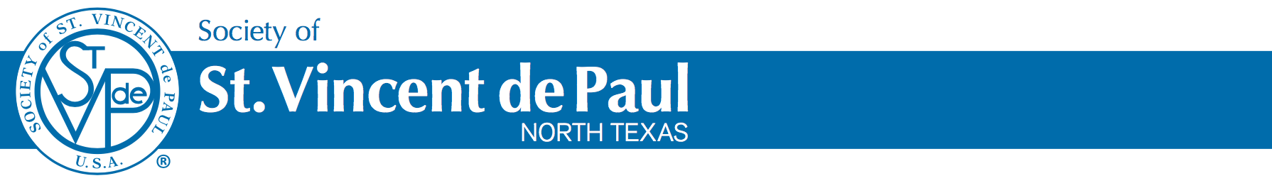




Payday Loan Relief

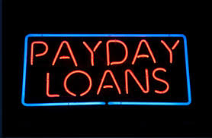
Are you struggling to make ends meet because of high-interest payday or auto title loan payments? The Society of St. Vincent de Paul offers a program to convert payday and auto title loans into a low-interest loan that can be paid off over 12-months. For more information, call your local conference of The Society of St. Vincent de Paul at XXX XXX XXXX and ask about the Mini Loan Program.

