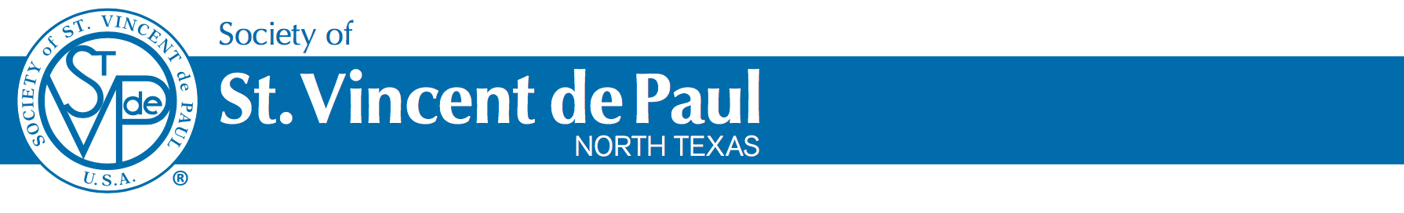

Payday Loan Relief
Mini Loan Program

The Society of St. Vincent de Paul offers a program to convert payday and auto title loans into a low-interest loan that can be paid off over 12-months. For more information, call the Society of St. Vincent de Paul at 214 520 0650 x 124, or email helpme@svdpdallas.org and ask about the Mini Loan Program.

- Loans offered at 3% interest over 12 months
- Loans from $500 - $4,000
- Requirements:
- Source of Income with direct deposit to bank account
- Agree to automatic withdrawal of payment
- Agree to Budget counseling

********Savings incentive********

